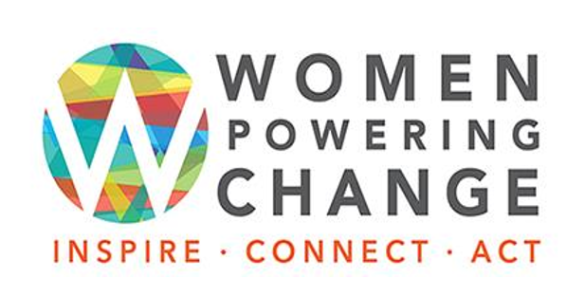
Communications and
Social Media Toolkit

Please use the following tools to help guide your social media and communications activity for supporting the Women Powering Change event and your participation. Please personalize and share your own stories, photos and experiences as much as possible!

Event Background
Women Powering Change began when peace and security activist/philanthropist Cynda Collins Arsenault recognized the incredible wealth of skills and passion of women who were leading change for/by/about women right here in Colorado. At the same time, she was also hearing from many women who felt disconnected from their own community and were not aware of the work being done locally and internationally to address and solve the issues we all face, e.g social, political, cultural, etc. She hosted a garden party in 2013 to showcase the work being done and connect these two groups. The response was overwhelming. Outgrowing her backyard, she hosted a second event one year later at Denver’s Redline Art Gallery, with over 500 people in attendance. Recognizing the power and potential of this event, other women stepped up to create a volunteer-led committee to carry Women Powering Change forward.

Women Powering Change has been sustained through the dedicated efforts of volunteers committed to furthering this vision. Annual events grew to over 1,000 attendees and after a brief pause due to the pandemic, we are once again responding to the calls to host Women Powering Change Expo event.

Women Powering Change is also proud to be a founding partner of Week of Women Colorado! Week of Women is a local initiative designed to celebrate women across Colorado and shine a light on issues impacting women in Colorado by highlighting an entire week of programming and events taking place across Colorado by various organizations and community groups. Week of Women will run from March 2 - 12, 2023, the week of International Women’s Day.

Social Media Recommendations
- Invite your followers to attend to learn about and engage with organizations for, by, and about women
- Create and share posts that provide information on women and social change
  - What are women doing, and what is being achieved?
- Share information and statistics about
  - Women involved in or leading nonprofit organizations
  - Challenges facing women and girls nationally/internationally
- Identify and share empowering, inspirational, and motivational quotes (see digital assets for examples)
- Use the hashtags: #WomenPoweringChange and #WeekofWomenCO
- Post 1 – 3 times per week

What would we like you to share and where?
Below are recommended social media themes for each channel.

Facebook | Showcase and tag partner organizations at the event, share the event via Facebook:  https://www.facebook.com/events/1596320650884543
Instagram | Screenshot and share logos from all exhibiting organizations. Consider adding a photo that is inspirational, motivational, or showcases engagement in service activities. No links in posts on Instagram! People can add the registration link to their personal profile: https://www.womenpoweringchange.org
Twitter | It’s about the TAG & the hashtag… #WomenPoweringChange #WeekofWomenCO  Tag your target audience with an “@” with copy representative of YOUR voice and share your invitation to connect.
LinkedIn/LinkedIn Groups | SEARCH for Women’s Groups in Denver – think about your industry. If you are in financial services, post in groups to attract other women within your industry.

Sample Posts
- Facebook: Join women, individual donors, activists, and others working passionately to create change on March 2nd from 4 pm-7 pm at the Seawell Ballroom at DCPA. Be part of the conversations about sustainability, social justice, gender equity, and more. The event is free. #WomenPoweringChange #WeekofWomenCO Registration is required https://www.womenpoweringchange.org

- Facebook: We cannot wait to join other organizations passionately impacting change locally and across the world. Be there on March 2nd from 4pm-7pm for the free #WomenPoweringChange event. Registration is required https://www.womenpoweringchange.org

- Twitter: Join me at #WomenPoweringChange on March 2nd to create intentional #socialchange in#Denver! Register today for free #WeekofWomenCO https://www.womenpoweringchange.org/

- Twitter: Will you be joining us and other dynamic women at the #WomenPoweringChange event on March 2nd? Learn more about our work around (insert topic/focus), and visit other orgs focused on issues around health, leadership, & equity and more. https://www.womenpoweringchange.org/

- LinkedIn: Join me at #WomenPoweringChange on March 2nd to create intentional social change in Denver! Register today for free #WeekofWomenCO https://www.womenpoweringchange.org/

- LinkedIn: Are you a woman creating change in our community? Join hundreds of other dynamic women who are working toward improving the world around us. Be there on March 2nd at the Seawell Ballroom at DCPA in Denver from 4 pm-7 pm. The event is free, but registration is required. https://www.womenpoweringchange.org/

- Instagram: Join us at #WomenPoweringChange on March 2nd to create intentional social change in Denver! Register today for free #WeekofWomenCO https://www.womenpoweringchange.org/

- Instagram: Local and global organizations are working towards creating social change. Join other empowered women in purpose-driven service on March 2nd at the Seawell Ballroom at DCPA from 4 pm-7 pm. It’s free, but registration is required. #WomenPoweringChange #Weekof WomenCO https://www.womenpoweringchange.org/

LOGO:
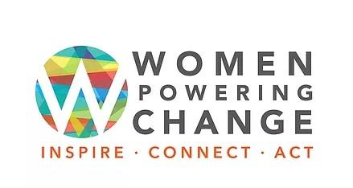

Possible Digital Assets (feel free to use!)
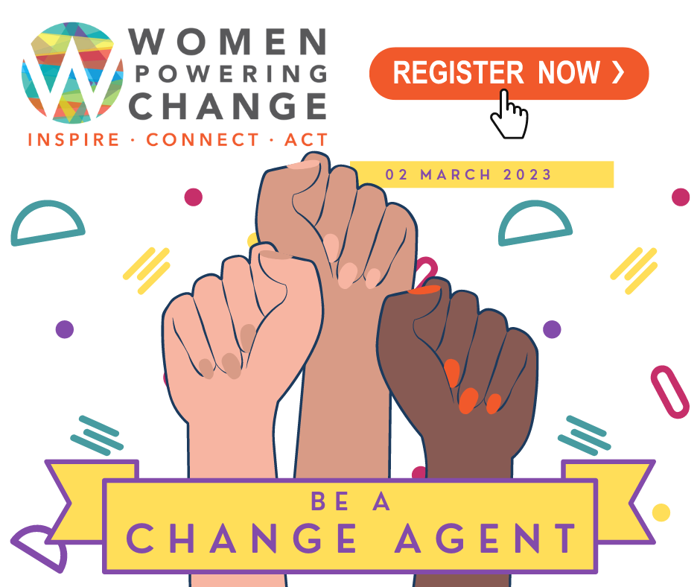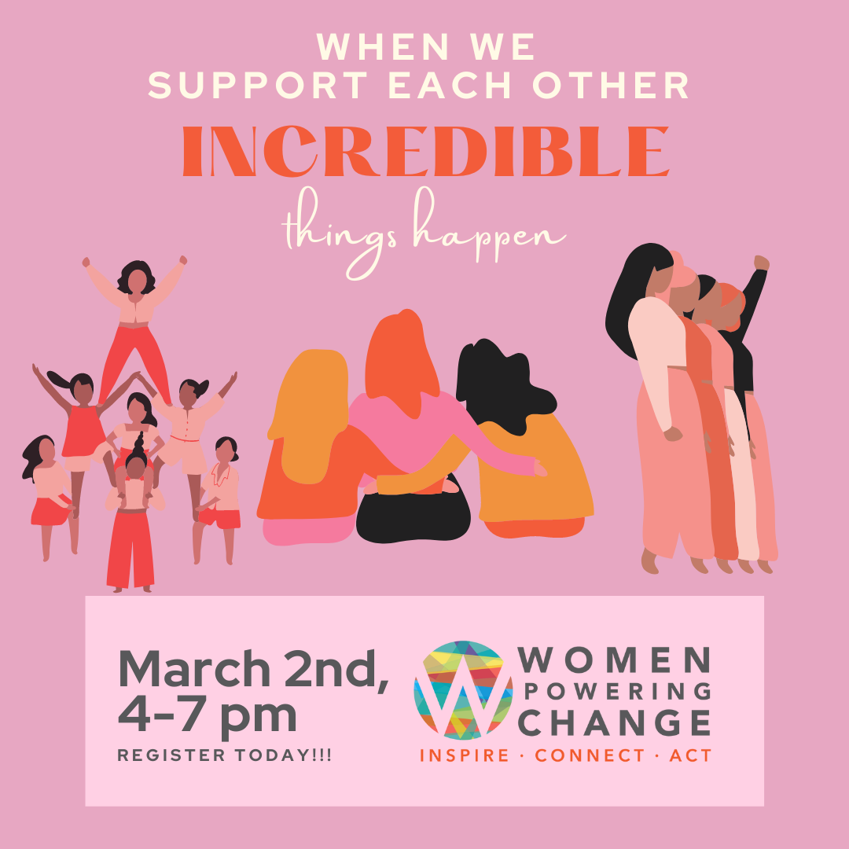
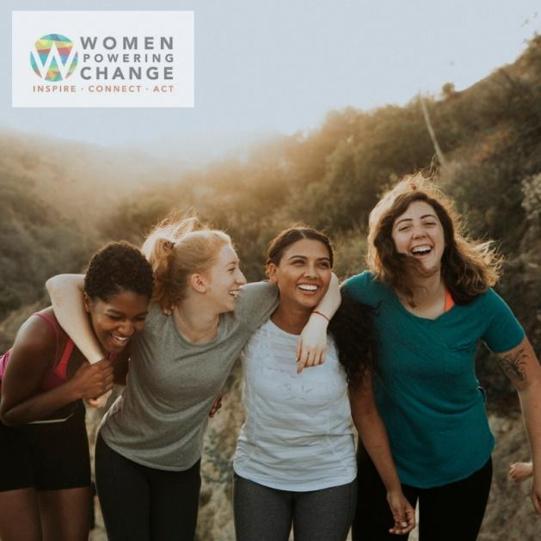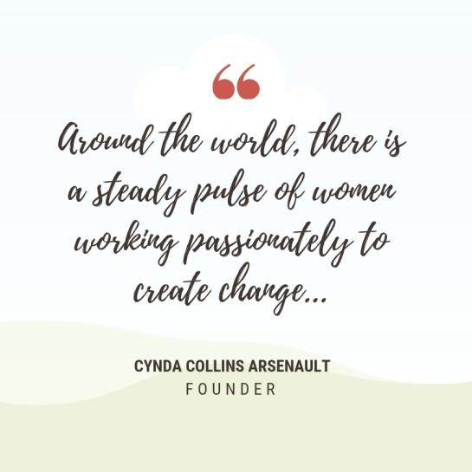

Suggested Website Language/ Newsletter Blurb (short)
Women Powering Change is proud to be a flagship event of the Week of Women in Colorado. Women Powering Change is the only event that brings together community members, leaders, activists, and philanthropists with Colorado organizations that are doing work to catalyze social change locally and globally. The event will take place on March 2nd from 4 pm-7 pm at the Seawell Ballroom at the Denver Center for Performing Arts. This annual event looks to engage women leaders of Colorado-based nonprofits & social impact organizations focused on advancing women & girls with those seeking to identify how to share & leverage their own resources to most effectively create a better world. The event is free, but registration is encouraged. https://www.womenpoweringchange.org/

Newsletter article: Long
Women Powering Change Features
Mission-Driven Organizations By, For, and About Women
Connect with more than 100 Colorado organizations on March 2, 2023

Become part of the circle of women who will join forces on March 2nd from 4 pm -7 pm at the Seawell Ballroom at the Denver Center for Performing Arts for the annual expo event hosted by Women Powering Change.

Founded by philanthropist Cynda Collins Arsenault in 2013 as “Women’s Work, Wisdom, and Wine,” Women Powering Change seeks to accelerate the social impact of women creating a just world by engaging the larger community in the inspiring work being done locally and globally by organizations in Colorado led by, for, or about women. “Around the world, there is a steady pulse of women working passionately to create change,” says Arsenault. “Women Powering Change 2023 is designed to connect like-minded women and men who can share ideas across sectors, glean inspiration from one another’s stories, and connect resources.”

This is the only event that brings together community members, leaders, activists, and philanthropists with Colorado organizations showcasing projects, programs, and initiatives that are amplifying social change to ensure a better world. The event serves as a unique opportunity to learn more about women's critical and necessary roles in creating a more sustainable and equitable world while connecting individuals with social change organizations.

These organizations will represent more than ten focus areas including youth, social and political equality, science and technology, leadership development, human rights, health & wellness, sustainability, poverty, creative arts, education, and economic development. Attendees are encouraged to be part of the conversations around self-development, human trafficking, domestic violence, entrepreneurship, microfinancing, affordable housing, food security, job training, and more.

Women Powering Change 2023 is free for guests and open to the public. Registration is required, and space is limited. Visit www.WomenPoweringChange.org to register today and discover what Colorado organizations are doing to create a better world and how you can engage, locally and globally.

